Design and Technology Faculty
Product Design
Activity 1. Product Evaluation
This activity gets children thinking about everyday objects. These can be objects found in the classroom, strange and unusual objects you have collected, or objects which the children bring in from home.
1) Choose an object.
2) Discuss it and examine it closely. (may require an adult)
3) Talk about the following things in relation to the object:
- What materials the object is made from.
- Why those materials have been used to make the object (links with Materials and their Properties - Science)
- How the materials were combined / changed to make the object.
- How the object works.
- How well the object has been designed.
- Would the children modify the object in any way to make it more effective in doing its job?
Depending on the object, and with the owner's permission (and with supervision), the children could take apart the object, in order to look more closely at it. The children could also be set some extra work based on this activity, i.e. designing a object which does the same job / redesigning the object to improve its sustainability ie make it more environmentally friendly.
Activity 2. Packaging Design
This project involves designing a package for a food product. The food product in question could be specified by the teacher, or the children could choose for themselves.
1) Look at packaging made by food companies. What are they made out of? Why was this material chosen? What information can be found on the packaging (weight, product description, ingredients, logo, picture, nutrition information...).
2) Disassemble the packaging. How was it made? If the packaging is a box, what is the net like? Are there any other nets which will make the same box?
3) Discuss what happens to the materials once they have been used. Can they be recycled? Can they be used again? Can the packaging be made from any other materials?
4) Ask the children to design their own packaging, using the information that they have learnt from the previous activities. They could even design a few different types of packaging, and conduct some consumer research (asking other children) to find out the favourite.
5) While the children are designing their packaging, they should consider the following:
- Appearance - Is it attractive and eye-catching? Does it make the consumer want to pick it up and look at the contents?
- Function - Does it hold the contents safely and securely? Is it suitable for its intended job?
- Safety - Will the food be kept fresh? Will it be damaged?
- Reliability - Is the box strong enough for the purpose? Will it last for the intended storage life?
6) Once the product is designed, the children can make their packaging.
7) When the packaging has been made, they can evaluate their product, and they could conduct some more research to find out what others think.
8) The children could also create some advertising to promote their product. This could be in the form of a poster, a TV advert, or a radio advert.
Activity 3. Making
Making Kites has a number of benefits:
- Kite making is cross-curricular, involving Maths (shape and space work), Art, and Design and Technology.
- Kite making involves working in 2D and 3D.
- Can be used as topic work.
- Can be used to reinforce work on recognising 2D and 3D shapes.
- Can be used to discuss how different shapes can connect together, e.g. two triangles make a kite shape.
- Kites (both 2D and 3D) can be made from different shapes including hexagons, pentagons, triangles, cuboids etc. using art straws and tissue paper.

Activity 4. Renewable energy
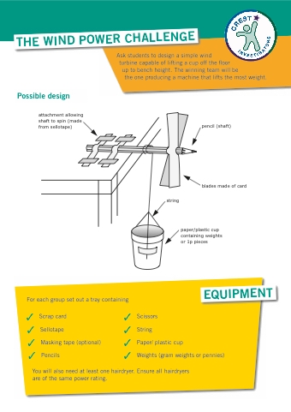
Design and Technology Faculty
Food
Activity 1. Eatwell Guide
This activity gets children thinking about a balanced and healthy diet.
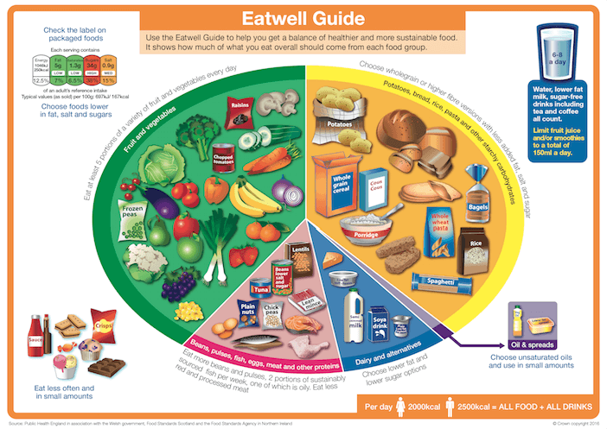

- Discuss the Eatwell Guide. Talk through the following things: (requires an adult)
- What does the Eatwell Guide promote?
- Talk through which foods are in each section.
- Discuss recommendation for each section such as how many portions of fruit and vegetables should you have each day.

- Draw your own Eatwell Guide. Include:
- Recommendations for each section
- Name for each section
- Draw foods in each section.

- Create a food diary (example below).
- Track what you have for breakfast, dinner and tea.
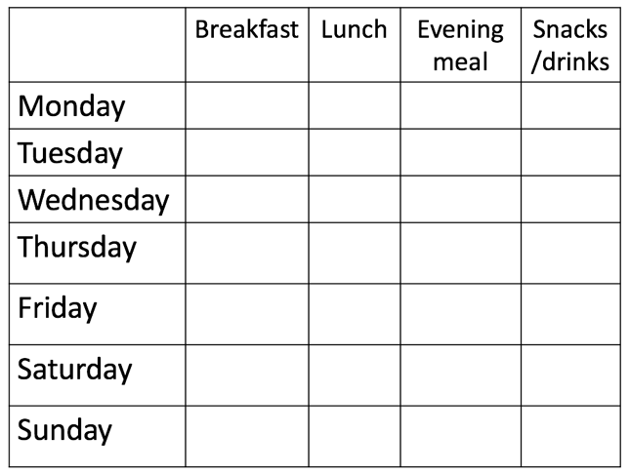
- Evaluation how well it fits in with the Eatwell Guide.

Activity 2. Health and Safety in the food room.
Task 1: Look at the image below and circle as many hazards as you can see.

Task 2: List 8 ways how the image above could be safer.

Activity 3. Equipment in the food room.
Task 1: Use the table below to identify the equipment in the pictures.
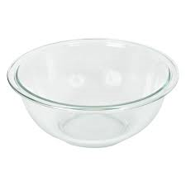
1
2
3
4
5
6
7
8
9
10
11
12
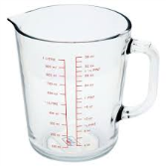
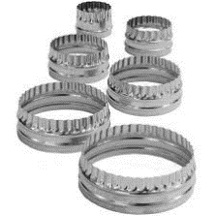
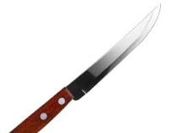
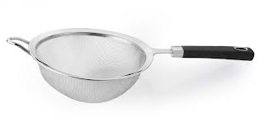
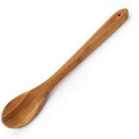
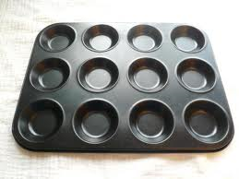
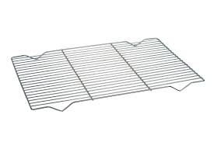
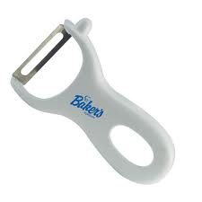
12
6
2
3
4
11
1
5
8
10
9

7

Website to help: https://www.foodafactoflife.org.uk

Textiles
Activity 1. Inspiration
This activity gets children thinking about how a mood board can provide inspiration for designing and making a product.
Task 1 – Create a mind map of a range of foods that you could use as inspiration for designing and making a pin cushion. Example below:
Food
Pizza slice
Burger
Strawberry
M&M
Pancakes
Kiwi
Doughnuts
Ice lolly

Task 2 – using your sider diagram gather a range of images. Put them together to create a mood board. You don’t have to use a computer to do this you can use magazines to create texture.

