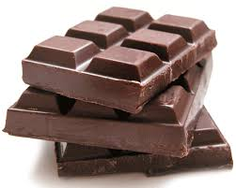
- Which people first discovered chocolate?

- What does Xocolatl mean?

- On what occasions did the ancient Central-Americans drink chocolate?

- What did the Aztecs use cocoa bean for?

- Who was not allowed to drink chocolate under the Aztecs?

- How many cups of chocolate did Montezuma drink every day?
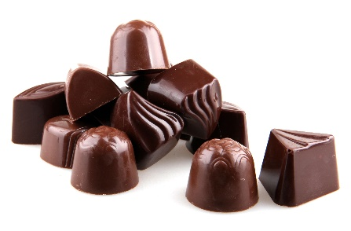
- How many beans for a juicy rabbit?

- How long did the Spanish keep their new secret?

- Why did the English pirates burn the ship full of cocoa beans?

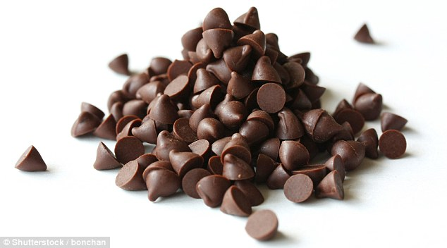
- Who invented hot chocolate?

- Which king had hot chocolate at his wedding?

- Where was the world’s first chocolate shop?

- Which company invented the first chocolate bar?

- Which is the biggest chocolate company in England?

- Put the following ‘chocolate masters’ in chronological order:

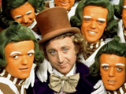
Spanish English Mayans Dutch Aztecs French

Tie Break: How many Oompa Loompas were there in the 2005 film Charlie and the Chocolate Factory?

