

**Name:**

**Form:**

[](https://www.google.co.uk/url?sa=i&rct=j&q=&esrc=s&source=images&cd=&cad=rja&uact=8&ved=&url=https://www.123rf.com/photo_23820615_hairy-green-monster-cartoon.html&bvm=bv.122676328,d.ZGg&psig=AFQjCNHaNJWG-PBJ-gmGlsNdafOR2ENi3A&ust=1464094282653744)[](https://www.google.co.uk/url?sa=i&rct=j&q=&esrc=s&source=images&cd=&cad=rja&uact=8&ved=0ahUKEwjFy6qAn_DMAhUILcAKHdgTDx0QjRwIBw&url=https://www.pinterest.com/pin/192599321540377320/&bvm=bv.122676328,d.ZGg&psig=AFQjCNHaNJWG-PBJ-gmGlsNdafOR2ENi3A&ust=1464094282653744)

[](https://www.google.co.uk/url?sa=i&rct=j&q=&esrc=s&source=images&cd=&cad=rja&uact=8&ved=0ahUKEwinnOvAn_DMAhVCCMAKHdPKA5sQjRwIBw&url=https://www.pinterest.com/pin/244883298462805639/&bvm=bv.122676328,d.ZGg&psig=AFQjCNHaNJWG-PBJ-gmGlsNdafOR2ENi3A&ust=1464094282653744)

**Science Transition Project**

All of the staff at Graham School are really excited about the learning journey that you are about to start. In this booklet we have created a range of exciting and engaging Science tasks which we would like you to complete and hand in on your first Science lesson in September. It is really important that you complete the work to the very best of your ability; this will help your Science teacher know what things you can do really well, and what things you could do with an extra bit of help with. Zig, Zag and Zorg really want to find out about science. Can you help them so they can report back to planet ZOOPITOR

We look forward to reading your work,

Miss Swinton, Director of Science

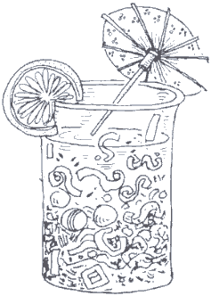

**Silly Mixtures**

Zig knows that things can get mixed up and they can then be separated. Zig has created a mixture that is similar to the soil on his planet. Your challenge is to try and separate all the different substances from your mixture.

# **Your mixture contains:** Sand, Salt, Marbles, Polystyrene, Lentils, Iron fillings

**Equipment:** 6 Petri dishes, 1 Sieve,1 Spoon, 1 funnel, 1 magnet, 1 piece of Filter paper

(There may be some techniques you may wish to use, not listed)

**Sieving, Decanting, Filtering, Evaporation**

Sand\_\_\_\_\_\_\_\_\_\_\_\_\_\_\_\_\_\_\_\_\_\_\_\_\_\_\_\_\_\_\_\_\_\_\_\_\_\_\_\_\_\_\_\_\_\_\_\_\_\_\_\_\_\_\_\_\_\_\_\_\_\_\_\_\_\_\_\_\_\_\_\_\_\_\_\_\_\_\_\_\_\_\_\_

Salt\_\_\_\_\_\_\_\_\_\_\_\_\_\_\_\_\_\_\_\_\_\_\_\_\_\_\_\_\_\_\_\_\_\_\_\_\_\_\_\_\_\_\_\_\_\_\_\_\_\_\_\_\_\_\_\_\_\_\_\_\_\_\_\_\_\_\_\_\_\_\_\_\_\_\_\_\_\_\_\_\_\_\_\_\_

Marbles\_\_\_\_\_\_\_\_\_\_\_\_\_\_\_\_\_\_\_\_\_\_\_\_\_\_\_\_\_\_\_\_\_\_\_\_\_\_\_\_\_\_\_\_\_\_\_\_\_\_\_\_\_\_\_\_\_\_\_\_\_\_\_\_\_\_\_\_\_\_\_\_\_\_\_\_\_\_\_\_

Polystyrene\_\_\_\_\_\_\_\_\_\_\_\_\_\_\_\_\_\_\_\_\_\_\_\_\_\_\_\_\_\_\_\_\_\_\_\_\_\_\_\_\_\_\_\_\_\_\_\_\_\_\_\_\_\_\_\_\_\_\_\_\_\_\_\_\_\_\_\_\_\_\_\_\_\_\_\_

Lentils\_\_\_\_\_\_\_\_\_\_\_\_\_\_\_\_\_\_\_\_\_\_\_\_\_\_\_\_\_\_\_\_\_\_\_\_\_\_\_\_\_\_\_\_\_\_\_\_\_\_\_\_\_\_\_\_\_\_\_\_\_\_\_\_\_\_\_\_\_\_\_\_\_\_\_\_\_\_\_\_\_\_

Iron fillings\_\_\_\_\_\_\_\_\_\_\_\_\_\_\_\_\_\_\_\_\_\_\_\_\_\_\_\_\_\_\_\_\_\_\_\_\_\_\_\_\_\_\_\_\_\_\_\_\_\_\_\_\_\_\_\_\_\_\_\_\_\_\_\_\_\_\_\_\_\_\_\_\_\_\_\_

You will need to divide the separation process into two sections,

[](https://www.google.co.uk/url?sa=i&rct=j&q=&esrc=s&source=images&cd=&cad=rja&uact=8&ved=0ahUKEwinnOvAn_DMAhVCCMAKHdPKA5sQjRwIBw&url=https://www.pinterest.com/pin/244883298462805639/&bvm=bv.122676328,d.ZGg&psig=AFQjCNHaNJWG-PBJ-gmGlsNdafOR2ENi3A&ust=1464094282653744)WET and DRY. Write down how you are going to carry out this experiment, thinking about what will be left in each section and how the substances will be separated.

Write it down in points form so that it is easier for you to follow.

# For example…………………

1. Put dry mixture through a sieve to separate the large particles from the small ones…………… \_\_\_\_\_\_\_\_\_\_\_\_\_\_\_\_\_\_\_\_\_\_\_\_\_\_\_\_\_\_\_\_\_\_\_\_\_\_\_\_\_\_\_\_\_\_\_\_\_\_\_\_\_\_\_\_\_\_\_\_\_\_\_\_\_\_\_\_\_\_\_\_\_\_\_\_\_\_\_\_\_\_\_\_\_\_\_\_\_\_\_\_\_\_\_\_\_\_\_\_\_\_\_\_\_\_\_\_\_\_\_\_\_\_\_\_\_­­­­­­­­\_\_\_\_\_\_\_\_\_\_\_\_\_\_\_\_\_\_\_\_\_\_\_\_\_\_\_\_\_\_\_\_\_\_\_\_\_\_\_\_\_\_\_\_\_\_\_\_\_
2. \_\_\_\_\_\_\_\_\_\_\_\_\_\_\_\_\_\_\_\_\_\_\_\_\_\_\_\_\_\_\_\_\_\_\_\_\_\_\_\_\_\_\_\_\_\_\_\_\_\_\_\_\_\_\_\_\_\_\_\_\_\_\_\_\_\_\_\_\_\_\_\_\_\_\_\_\_\_\_\_\_\_\_\_\_\_\_\_\_\_\_\_\_\_\_\_\_\_\_\_\_\_\_\_\_\_\_\_\_\_\_\_\_\_\_\_\_\_\_\_\_\_\_\_\_\_\_\_\_\_\_\_\_\_\_\_\_\_\_\_\_\_\_\_\_\_\_\_\_\_\_\_\_\_\_\_\_\_\_\_\_\_\_\_\_\_
3. \_\_\_\_\_\_\_\_\_\_\_\_\_\_\_\_\_\_\_\_\_\_\_\_\_\_\_\_\_\_\_\_\_\_\_\_\_\_\_\_\_\_\_\_\_\_\_\_\_\_\_\_\_\_\_\_\_\_\_\_\_\_\_\_\_\_\_\_\_\_\_\_\_\_\_\_\_\_\_\_\_\_\_\_\_\_\_\_\_\_\_\_\_\_\_\_\_\_\_\_\_\_\_\_\_\_\_\_\_\_\_\_\_\_\_\_\_\_\_\_\_\_\_\_\_\_\_\_\_\_\_\_\_\_\_\_\_\_\_\_\_\_\_\_\_\_\_\_\_\_\_\_\_\_\_\_\_\_\_\_\_\_\_\_\_\_
4. \_\_\_\_\_\_\_\_\_\_\_\_\_\_\_\_\_\_\_\_\_\_\_\_\_\_\_\_\_\_\_\_\_\_\_\_\_\_\_\_\_\_\_\_\_\_\_\_\_\_\_\_\_\_\_\_\_\_\_\_\_\_\_\_\_\_\_\_\_\_\_\_\_\_\_\_\_\_\_\_\_\_\_\_\_\_\_\_\_\_\_\_\_\_\_\_\_\_\_\_\_\_\_\_\_\_\_\_\_\_\_\_\_\_\_\_\_\_\_\_\_\_\_\_\_\_\_\_\_\_\_\_\_\_\_\_\_\_\_\_\_\_\_\_\_\_\_\_\_\_\_\_\_\_\_\_\_\_\_\_\_\_\_\_\_\_
5. \_\_\_\_\_\_\_\_\_\_\_\_\_\_\_\_\_\_\_\_\_\_\_\_\_\_\_\_\_\_\_\_\_\_\_\_\_\_\_\_\_\_\_\_\_\_\_\_\_\_\_\_\_\_\_\_\_\_\_\_\_\_\_\_\_\_\_\_\_\_\_\_\_\_\_\_\_\_\_\_\_\_\_\_\_\_\_\_\_\_\_\_\_\_\_\_\_\_\_\_\_\_\_\_\_\_\_\_\_\_\_\_\_\_\_\_\_\_\_\_\_\_\_\_\_\_\_\_\_\_\_\_\_\_\_\_\_\_\_\_\_\_\_\_\_\_\_\_\_\_\_\_\_\_\_\_\_\_\_\_\_\_\_\_\_\_
6. \_\_\_\_\_\_\_\_\_\_\_\_\_\_\_\_\_\_\_\_\_\_\_\_\_\_\_\_\_\_\_\_\_\_\_\_\_\_\_\_\_\_\_\_\_\_\_\_\_\_\_\_\_\_\_\_\_\_\_\_\_\_\_\_\_\_\_\_\_\_\_\_\_\_\_\_\_\_\_\_\_\_\_\_\_\_\_\_\_\_\_\_\_\_\_\_\_\_\_\_\_\_\_\_\_\_\_\_\_\_\_\_\_\_\_\_\_\_\_\_\_\_\_\_\_\_\_\_\_\_\_\_\_\_\_\_\_\_\_\_\_\_\_\_\_\_\_\_\_\_\_\_\_\_\_\_\_\_\_\_\_\_\_\_\_\_
7. \_\_\_\_\_\_\_\_\_\_\_\_\_\_\_\_\_\_\_\_\_\_\_\_\_\_\_\_\_\_\_\_\_\_\_\_\_\_\_\_\_\_\_\_\_\_\_\_\_\_\_\_\_\_\_\_\_\_\_\_\_\_\_\_\_\_\_\_\_\_\_\_\_\_\_\_\_\_\_\_\_\_\_\_\_\_\_\_\_\_\_\_\_\_\_\_\_\_\_\_\_\_\_\_\_\_\_\_\_\_\_\_\_\_\_\_\_\_\_\_\_\_\_\_\_\_\_\_\_\_\_\_\_\_\_\_\_\_\_\_\_\_\_\_\_\_\_\_\_\_\_\_\_\_\_\_\_\_\_\_\_\_\_\_\_\_

|  |  |  |
| --- | --- | --- |
| Choose a task which reflects your ability | | |
| **Batting for Bronze**    Below Level 4 | **Shooting for Silver**  MCSO00124_0000[1]  Level 4 | **Going for Gold**    Level 5-6 |
| - Describe simply how to separate solid particles using a sieve  - sort materials according to whether they dissolve or not  - Recognise that when a solid dissolves it does not disappear | * Use the keywords given above * Identify the correct equipment used for each separation technique * Select the correct technique | * Describe dissolving * Use the words solute and solvent * Use the idea of particles to describe what is happening |

Zig and Zorg were watching a dog eat a bone.

Are bones living?

They were wondering if the bone was living or non-living.

[](https://www.google.co.uk/url?sa=i&rct=j&q=&esrc=s&source=images&cd=&cad=rja&uact=8&ved=0ahUKEwjFy6qAn_DMAhUILcAKHdgTDx0QjRwIBw&url=https://www.pinterest.com/pin/192599321540377320/&bvm=bv.122676328,d.ZGg&psig=AFQjCNHaNJWG-PBJ-gmGlsNdafOR2ENi3A&ust=1464094282653744)

**ZAG:** The bone was never alive, it is just part of a living thing.

**ZORG:** The bone was alive because it came from a living thing, although I don’t think it’s alive now.



[](https://www.google.co.uk/url?sa=i&rct=j&q=&esrc=s&source=images&cd=&cad=rja&uact=8&ved=&url=https://www.123rf.com/photo_23820615_hairy-green-monster-cartoon.html&bvm=bv.122676328,d.ZGg&psig=AFQjCNHaNJWG-PBJ-gmGlsNdafOR2ENi3A&ust=1464094282653744)

Task

Zag and Zorg sent you an e-mail to ask if you could help them answer this question.

Write an email to Zag and Zorg to explain whether you think a bone is living or non-living.

*You might find the Information sheet of use to you when you form your reply.*

**Include:**

* Ideas from the Internet to help you decide
* Decide with whom you agree, Zag or Zorg
* Use scientific evidence to support your answer
* Discuss how sure you are about your answer
* Write in as much detail as you can

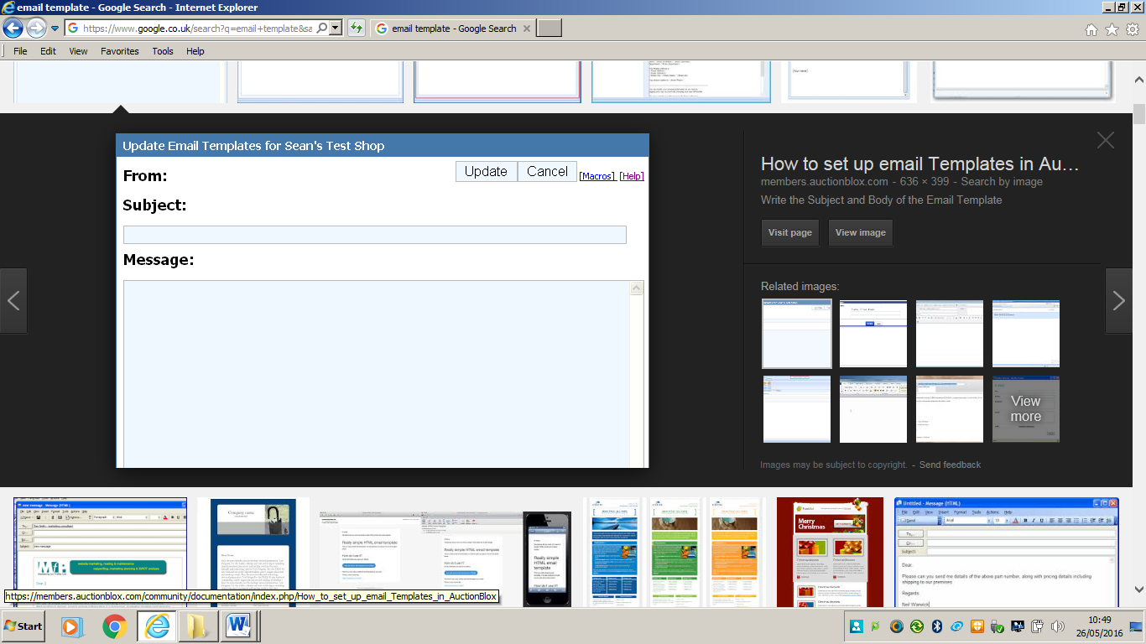

Key words

alive, bone, cell, dead, evidence, living, model

|  |  |  |
| --- | --- | --- |
| Choose a task which reflects your ability | | |
| **Batting for Bronze**    Below Level 4 | **Shooting for Silver**  MCSO00124_0000[1]  Level 4 | **Going for Gold**    Level 5-6 |
| -Decide who you agree with, Zag or Zorg.  -Compare the bone to a living organism and non-living object (say how it is similar or different to living or non-living objects).  -Use parts of the MRS GREN model to help you answer. | -Use MRS GREN to decide whether the bone is living.  -Describe which MRS GREN processes the bone displays.  -State the evidence that supports that the bone is living or not living. | -Describe how the processes identified in the MRS GREN model support your thinking about whether the bone is living or non-living. (Try to describe why those processes demonstrate life and how they apply to a bone.  -Recognise why it is difficult for scientists to state definitely that bones are living or not living. |

[](http://www.google.co.uk/url?sa=i&rct=j&q=&esrc=s&source=images&cd=&cad=rja&uact=8&ved=0ahUKEwiwv6KNzPfMAhXJDsAKHWvpDJMQjRwIBw&url=http://pngimg.com/img/objects/balloon&psig=AFQjCNHvgUWi6K1OfJG-Rh6SMZ_5CquTJw&ust=1464347030046837)Holiday to ZOOPITOR

[](https://www.google.co.uk/url?sa=i&rct=j&q=&esrc=s&source=images&cd=&cad=rja&uact=8&ved=0ahUKEwjFy6qAn_DMAhUILcAKHdgTDx0QjRwIBw&url=https://www.pinterest.com/pin/192599321540377320/&bvm=bv.122676328,d.ZGg&psig=AFQjCNHaNJWG-PBJ-gmGlsNdafOR2ENi3A&ust=1464094282653744)[](https://www.google.co.uk/url?sa=i&rct=j&q=&esrc=s&source=images&cd=&cad=rja&uact=8&ved=0ahUKEwinnOvAn_DMAhVCCMAKHdPKA5sQjRwIBw&url=https://www.pinterest.com/pin/244883298462805639/&bvm=bv.122676328,d.ZGg&psig=AFQjCNHaNJWG-PBJ-gmGlsNdafOR2ENi3A&ust=1464094282653744)

[](https://www.google.co.uk/url?sa=i&rct=j&q=&esrc=s&source=images&cd=&cad=rja&uact=8&ved=&url=https://www.123rf.com/photo_23820615_hairy-green-monster-cartoon.html&bvm=bv.122676328,d.ZGg&psig=AFQjCNHaNJWG-PBJ-gmGlsNdafOR2ENi3A&ust=1464094282653744)

Zig, Zag and Zorg have a party to say goodbye to Earth and are very thankful to all that they have learnt. They invite you to Zoopitor and they tell you it is similar to Jupiter. Do some internet research and find out about the conditions on the planet Jupiter. What will you have to pack in your suitcase to help you survive and why?

|  |  |  |
| --- | --- | --- |
| Choose a task which reflects your ability | | |
| **Batting for Bronze**    Below Level 4 | **Shooting for Silver**  MCSO00124_0000[1]  Level 4 | **Going for Gold**    Level 5-6 |
| * State what clothes to take with a simple reason * Recognise how the atmosphere is different * State the rough length of a day and a year | - Compare the day to earth  - Explain what clothes to take  - What special equipment will be needed ? | -Compare the difference in the length of the day and year compared to that on Earth and explain why there is a difference  -What special equipment will be needed and why ?  -Use a range of statistics in your description and explanations |